Deploy an application in Weblogic 12c

Navigate to Domain and Click Lock Edit

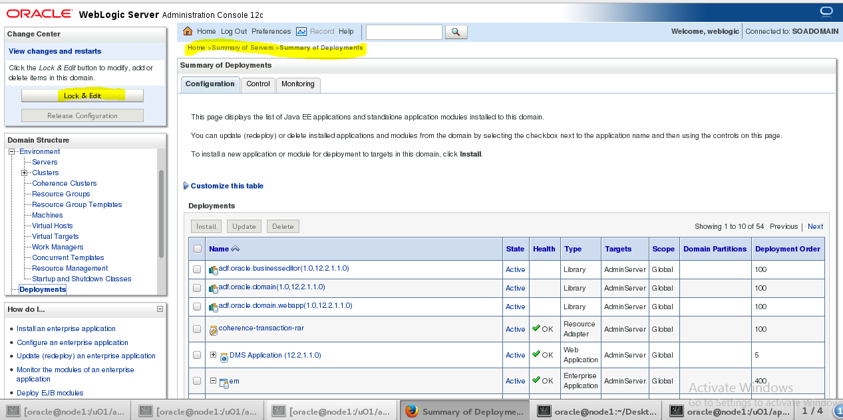

Click Install

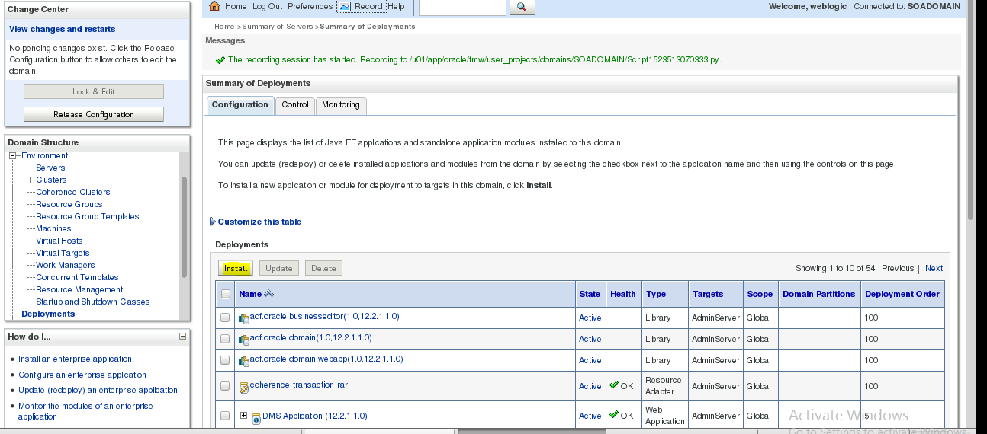

Select the application

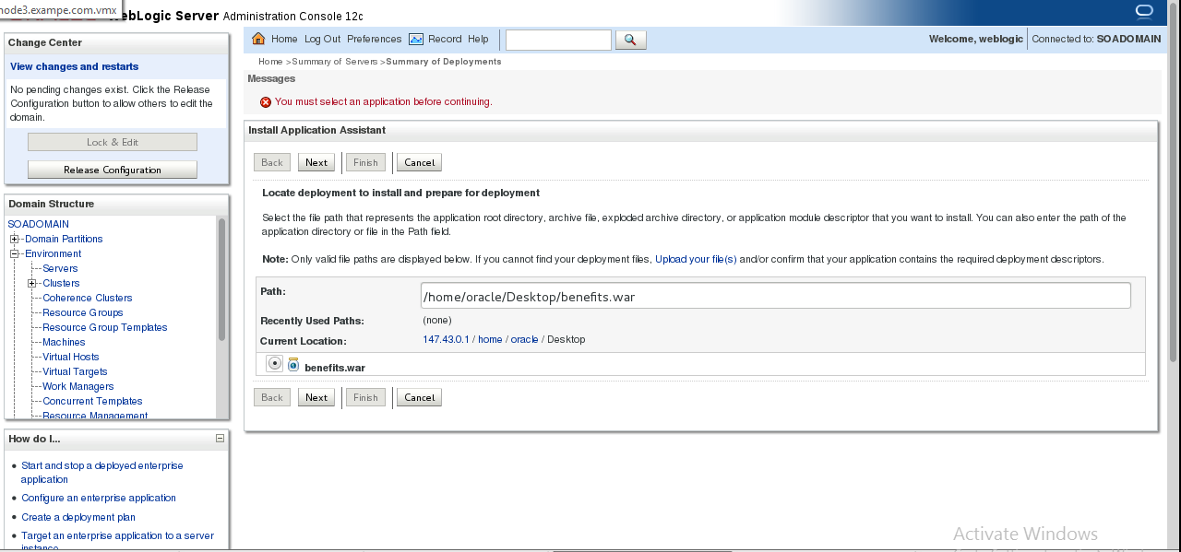

Install this application as Deployment

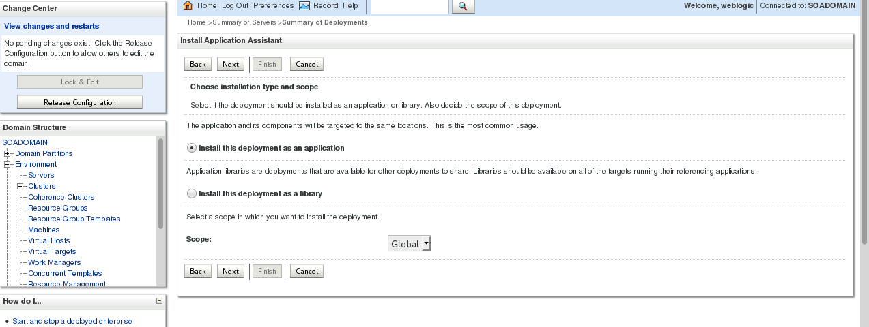

Choose the managed server

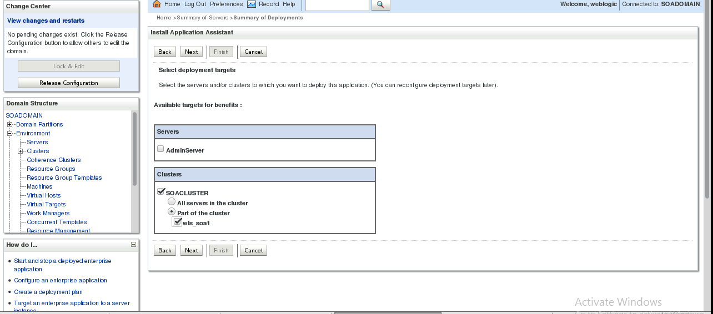

Finish Deploying

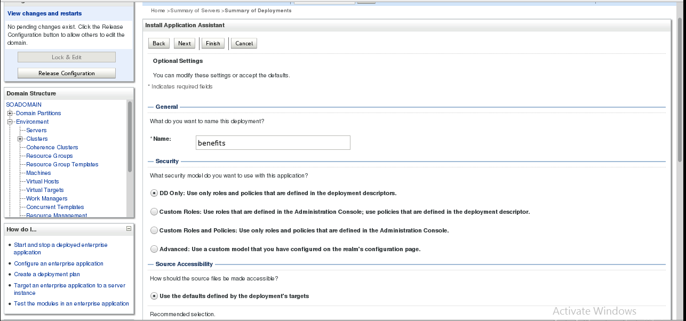

Activate the changes

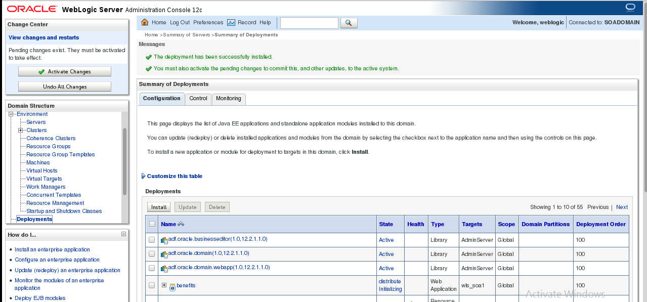

Start the application

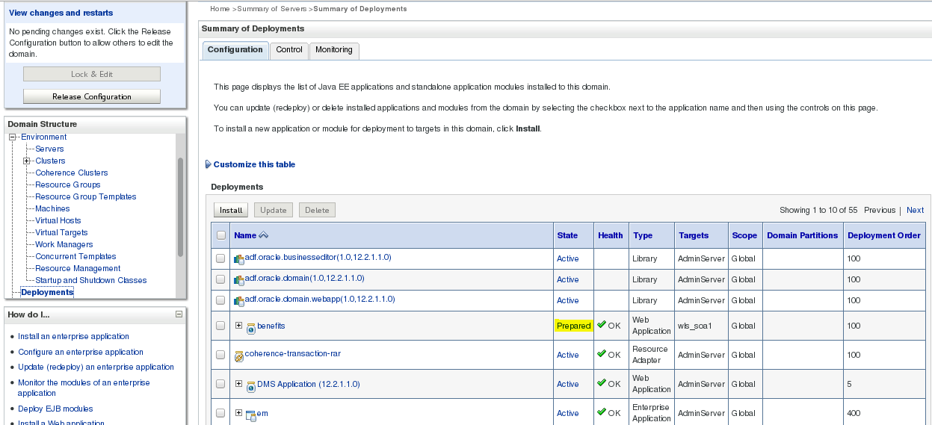

Click application->Control->Start

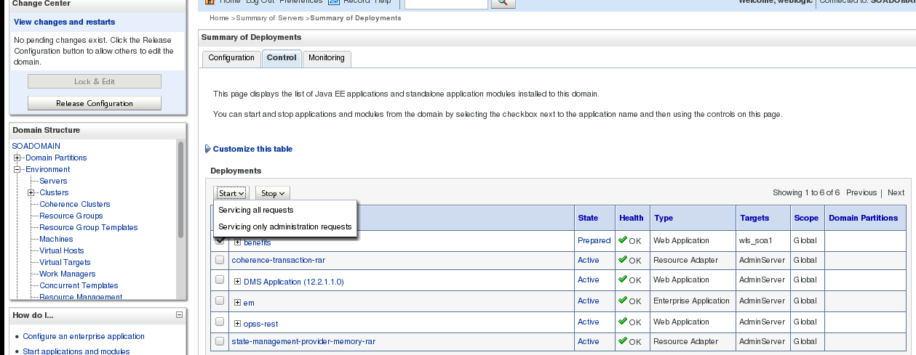

http://147.43.0.1:8003/benefits

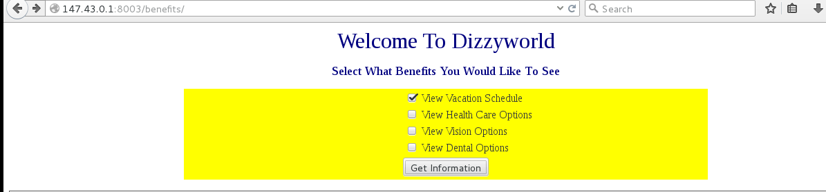

UNDEPLOY AN APPLICATION IN WEBLOGIC 12C

Click Lock Edit and Choose the application

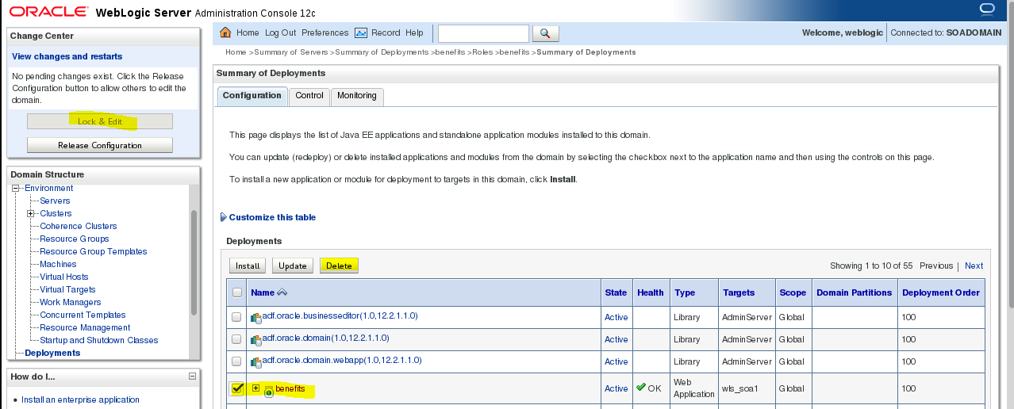

Stop the application

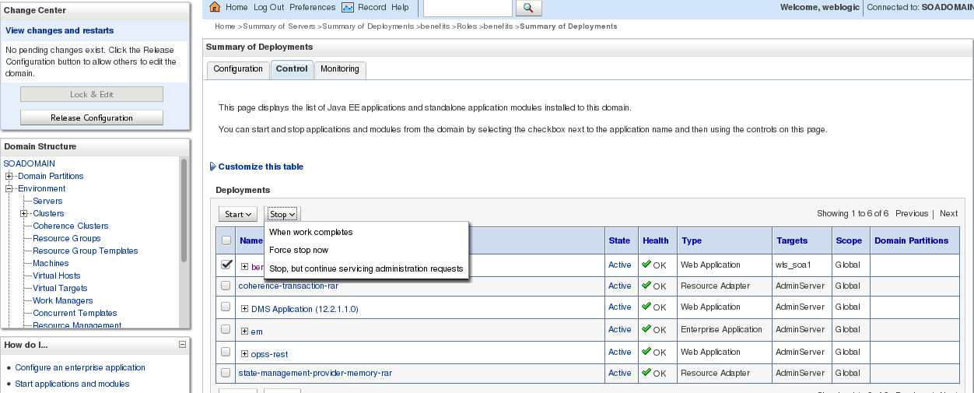

Status

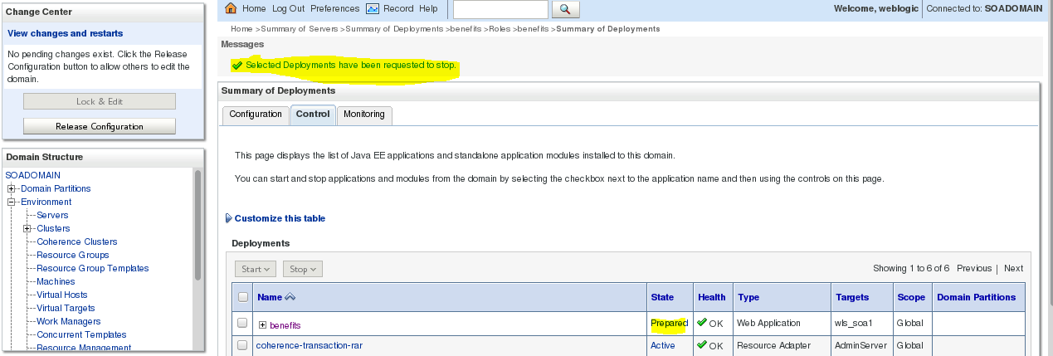

Delete the application



Status

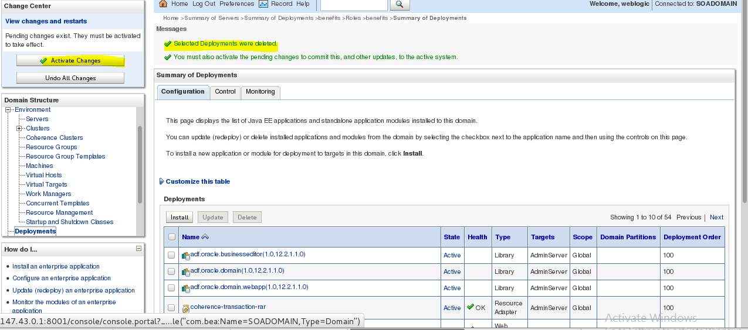

http://147.43.0.1:8003/benefits

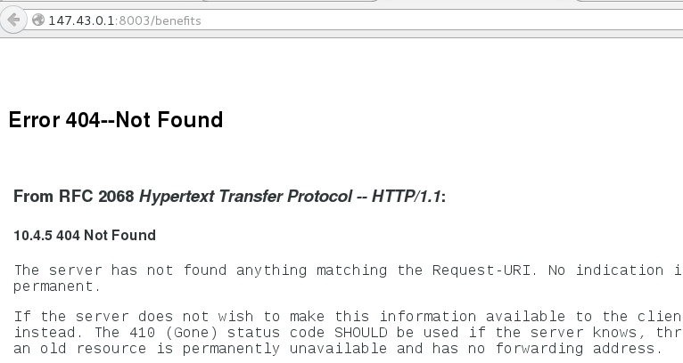

DEPLOY AN APPLICATION USING WLST

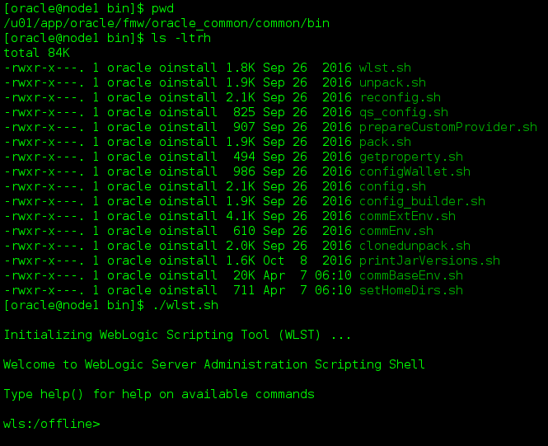

Connect the Admin Server

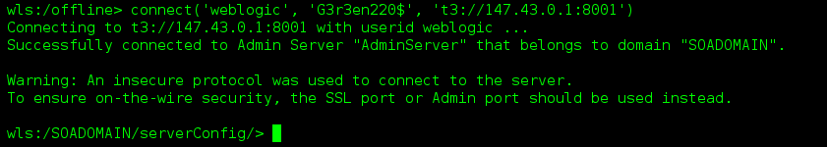

Click Lock Edit

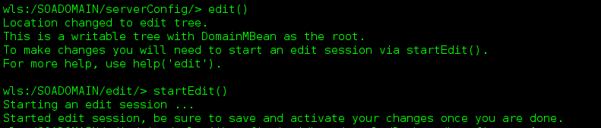

Deploy an Application

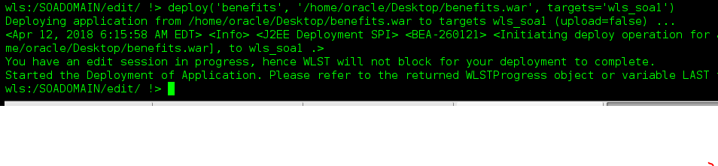

Save and Activate the changes

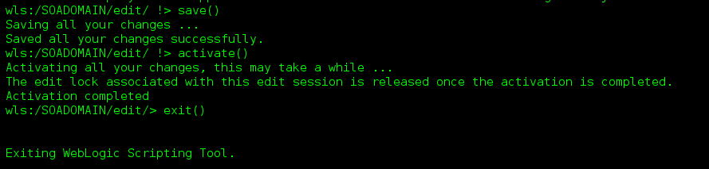

<http://147.43.0.1:8003/benefits>

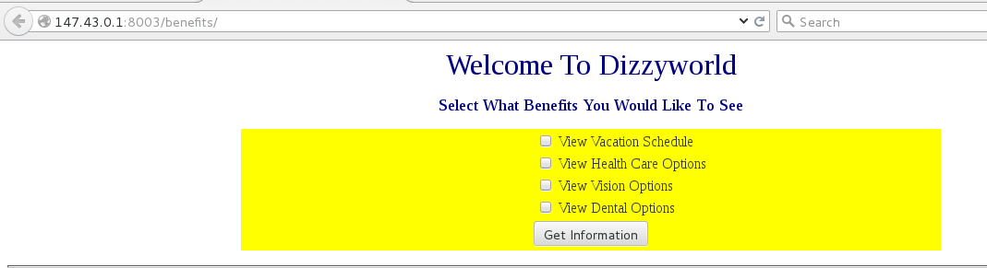

UNDEPLOY AN APPLICATION USING WLST



Connect Admin server

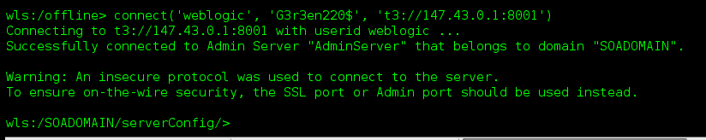

Click Lock Edit

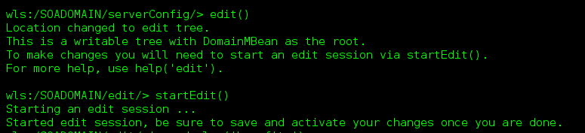

Undeploy the application

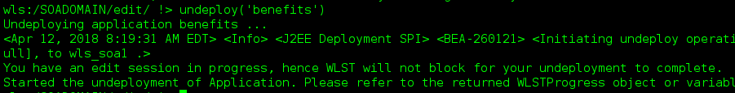

Activate changes



http://147.43.0.1:8003/benefits

